** Community District Education Council 26**

**New York City Department of Education**

***Address:* 61-15 Oceania Street, Bayside, NY 11364 *Phone:* (718) 631-6927 *Fax:* (718) 631-1347 *E-mail:* CEC26@schools.nyc.gov**

|  |  |  |  |  |  |
| --- | --- | --- | --- | --- | --- |
| **Albert Suhu**  *President of the Council* | | **Cassandra Louie**  *First Vice- President* | **Sae-Jung Lee**  *Second Vice President* | **Dennis Chan**  *Recording Secretary* | **Hsuante (Louis) Tsai**  *Treasurer* |
| *Council Members*:  **Ribhi Alam**  **Joanna Edwards**  **Sherry Gonzalez** | | **Sulinda Hong**  **Da Lin**  **Gilberto Mejia**  **Raymond Torres** | | *Student Members:*  **Asiyah Coppin**  **Frances Grodsky** | *District 26 Community Superintendent:*  **Anthony Inzerillo** | | |

**Resolution Demanding NO Changes to Specialized High School Admissions Criteria**

**Approved December 12, 2024**

**WHEREAS,** in 1972the Hecht-Calandra Act required, “Admissions to The Bronx High School of Science, Stuyvesant High School and Brooklyn Technical High School and such similar further special high schools which may be established shall be solely and exclusively by taking a competitive, objective and scholastic achievement examination, which shall be open to each and every child in the City of New York”[1]; and

**WHEREAS,** the lack of diversity in specialized high schools has spawned numerous knee-jerk reaction bills in the NYS legislature over the years to repeal or weaken the Hecht-Calandra Act; and

**WHEREAS,** opponents of the Specialized High School Admissions Test (SHSAT) claim the lack of diversity in specialized high schools is directly caused by an unfair test, but provide no evidence that the content (test questions) is biased against Black and Hispanic students; and

**WHEREAS,** statistics showing that Black students received only 4.5% of admission offers and Hispanic students 7.6% of offers given that these groups represent 24% and 41% of the student population, although very troubling, does not by itself demonstrate causality between the supposedly unfair SHSAT and the unfounded claim that the SHSAT harms Black and Hispanic students[2]; and

**WHEREAS,** opponents of the SHSAT claim other groups - white and Asians students achieve high scores on the SHSAT because their families have the financial means to pay for private test preparation. However, this is a false claim as numerous studies have concluded the improvement obtained from test prep is negligible. For example, the College Board, analyzed data from over 2 million SAT test takers and found that students who undertook test preparation scored an average of only 33 points higher on the SAT than those who did not participate in any test preparation activities[3]; and

**WHEREAS,** many factors could cause Black and Hispanic students to score poorly on the SHSAT. Low SHSAT scores among Black and Hispanic students is just a symptom of the underlying factors completely ignored by the opponents of the SHSAT, and therefore merely eliminating the SHSAT or diluting the weight of the SHSAT in admissions criteria does nothing to address the root causes of poor SHSAT scores among Black and Hispanic students; and

**WHEREAS,** NYS Math and ELA test data published by the DOE show that English and math proficiency rates among Black and Hispanic students are significantly lower than among Asian and white students across grades K-8 (see appendix), demonstrating that Black and Hispanic students perform poorly on the SHSAT likely because they are not as academically prepared as Asian and white students, starting as early as in kindergarten[4]; and

**WHEREAS,** SAT scores published by the DOE show results among Black and Hispanic students are significantly lower than those for Asian and white students, demonstrating that the achievement gap continues into 12th grade[5]; and

**WHEREAS,** the SHSAT serves an important purpose as a metric to gauge the achievement gap between Black and Hispanic students vs. Asian and white students; and

**THEREFORE, BE IT RESOLVED,** Community Education Council 26 demands legislators and others to cease their misguided rhetoric against the ills of the SHSAT and to instead work with the NYC Department of Education to perform root cause analysis and identify actionable methods to mitigate the persistent achievement gap that has plagued Black and Hispanic students. Recommended methods for performing root cause analysis include: Ishikawa Fishbone Diagram, Fault Tree Analysis, and Failure Mode and Effect Analysis (FMEA).

***During the CEC26 meeting held on December 12, 2024, the resolution was reviewed and unanimously approved by all***

***members in attendance.***

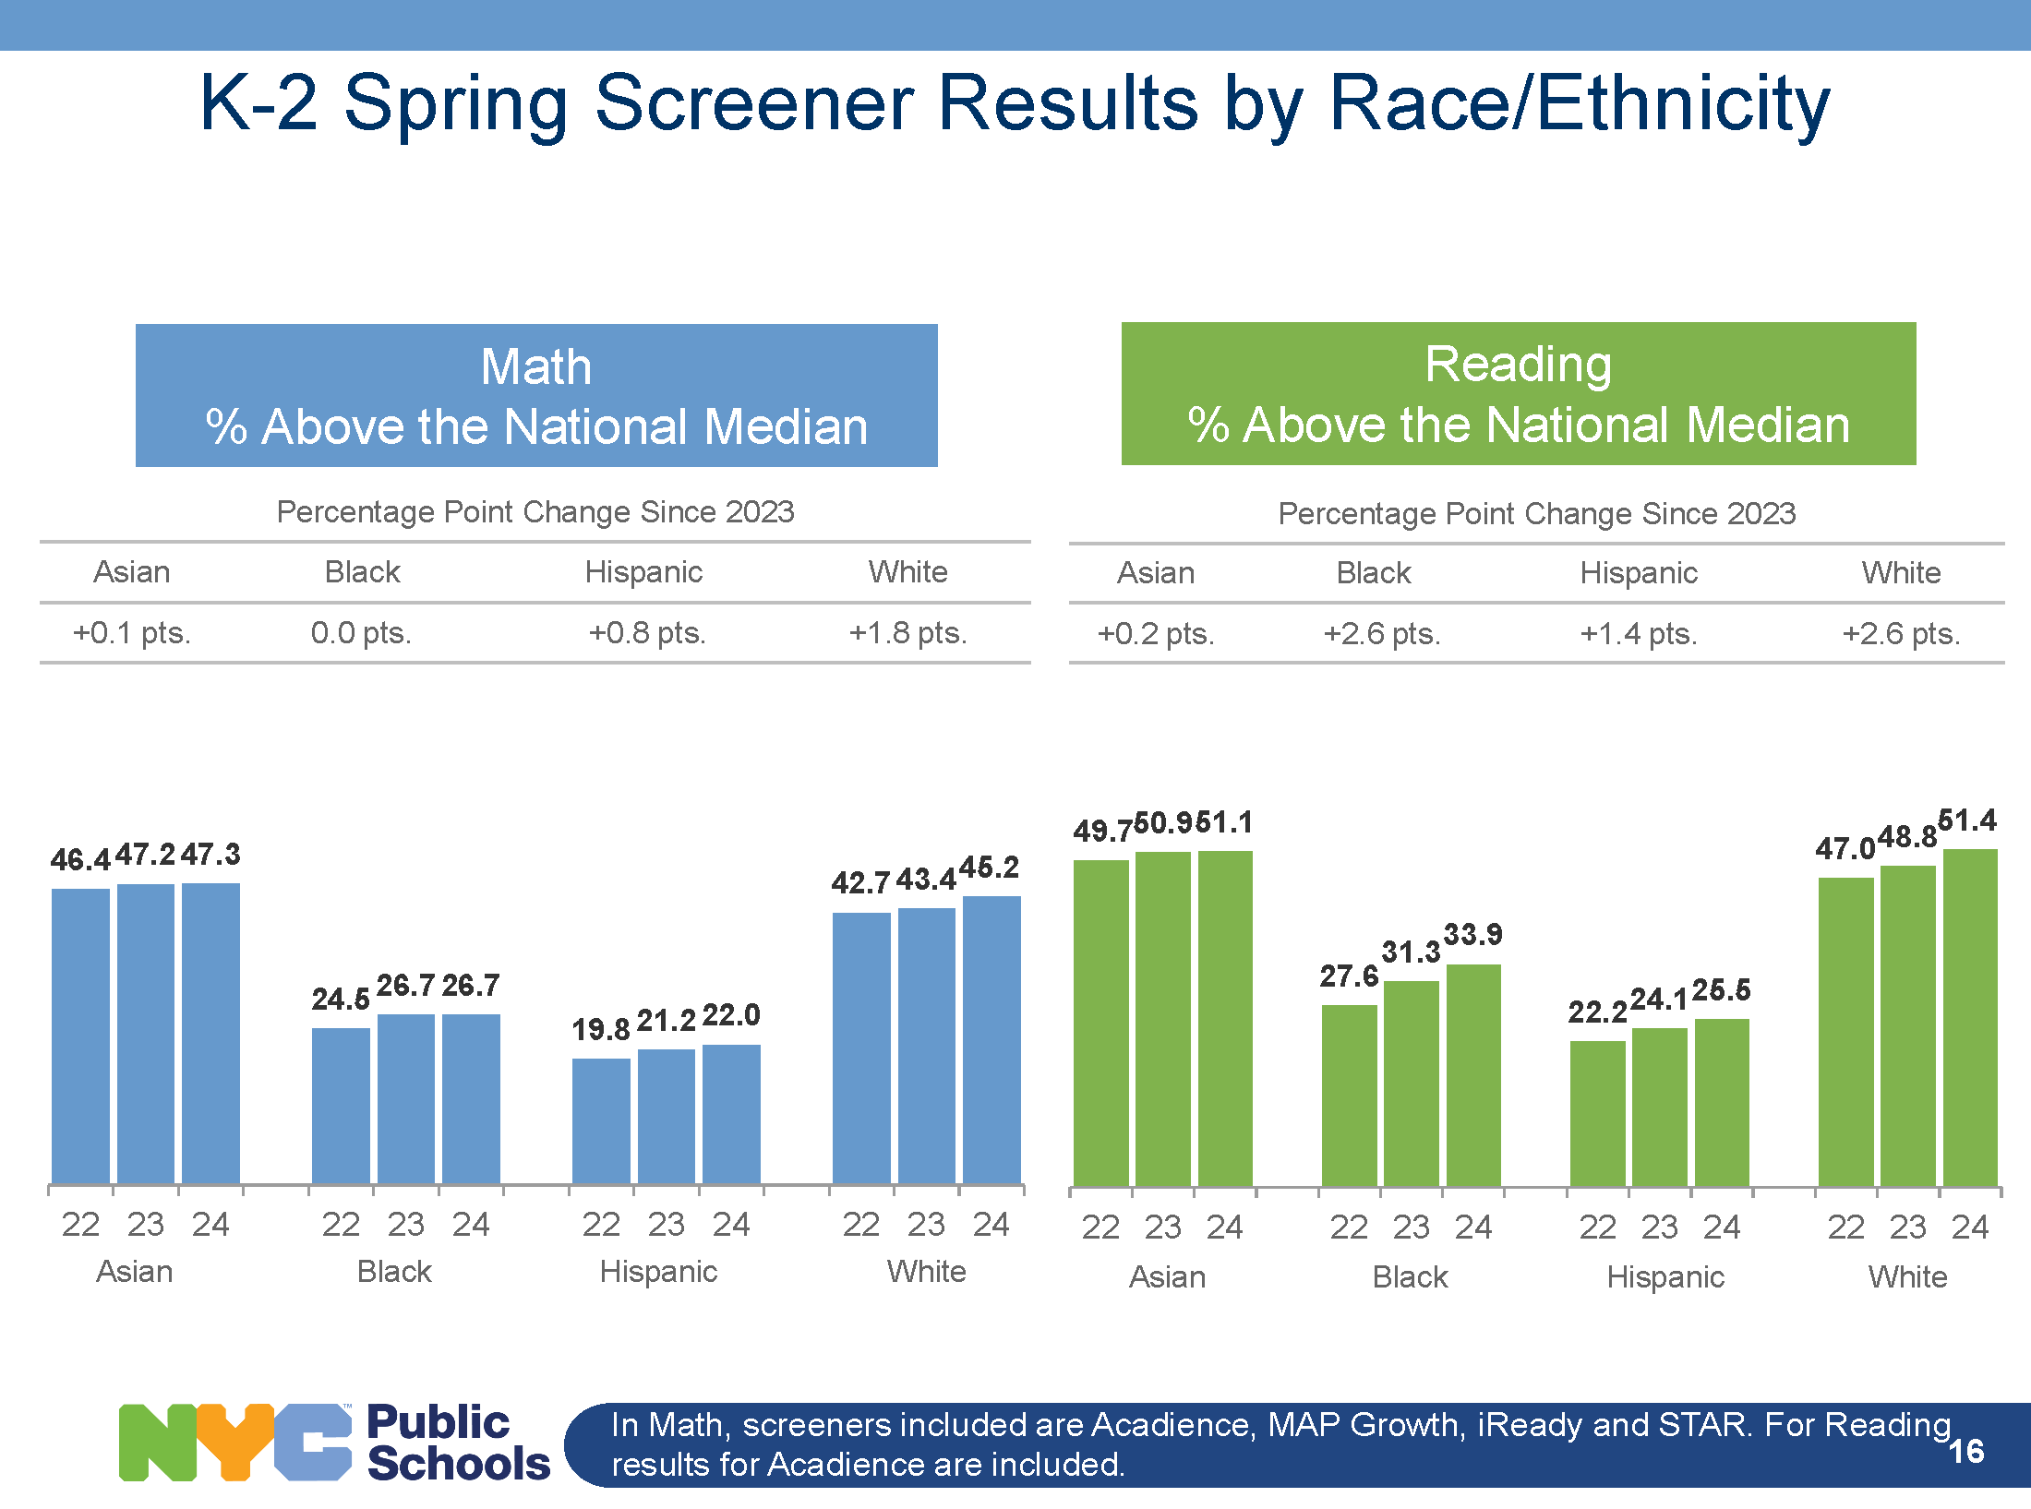

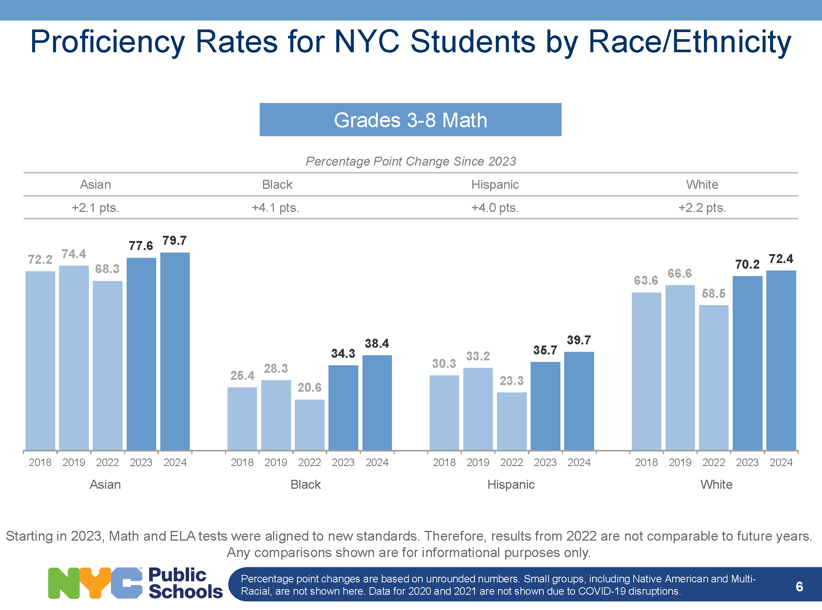

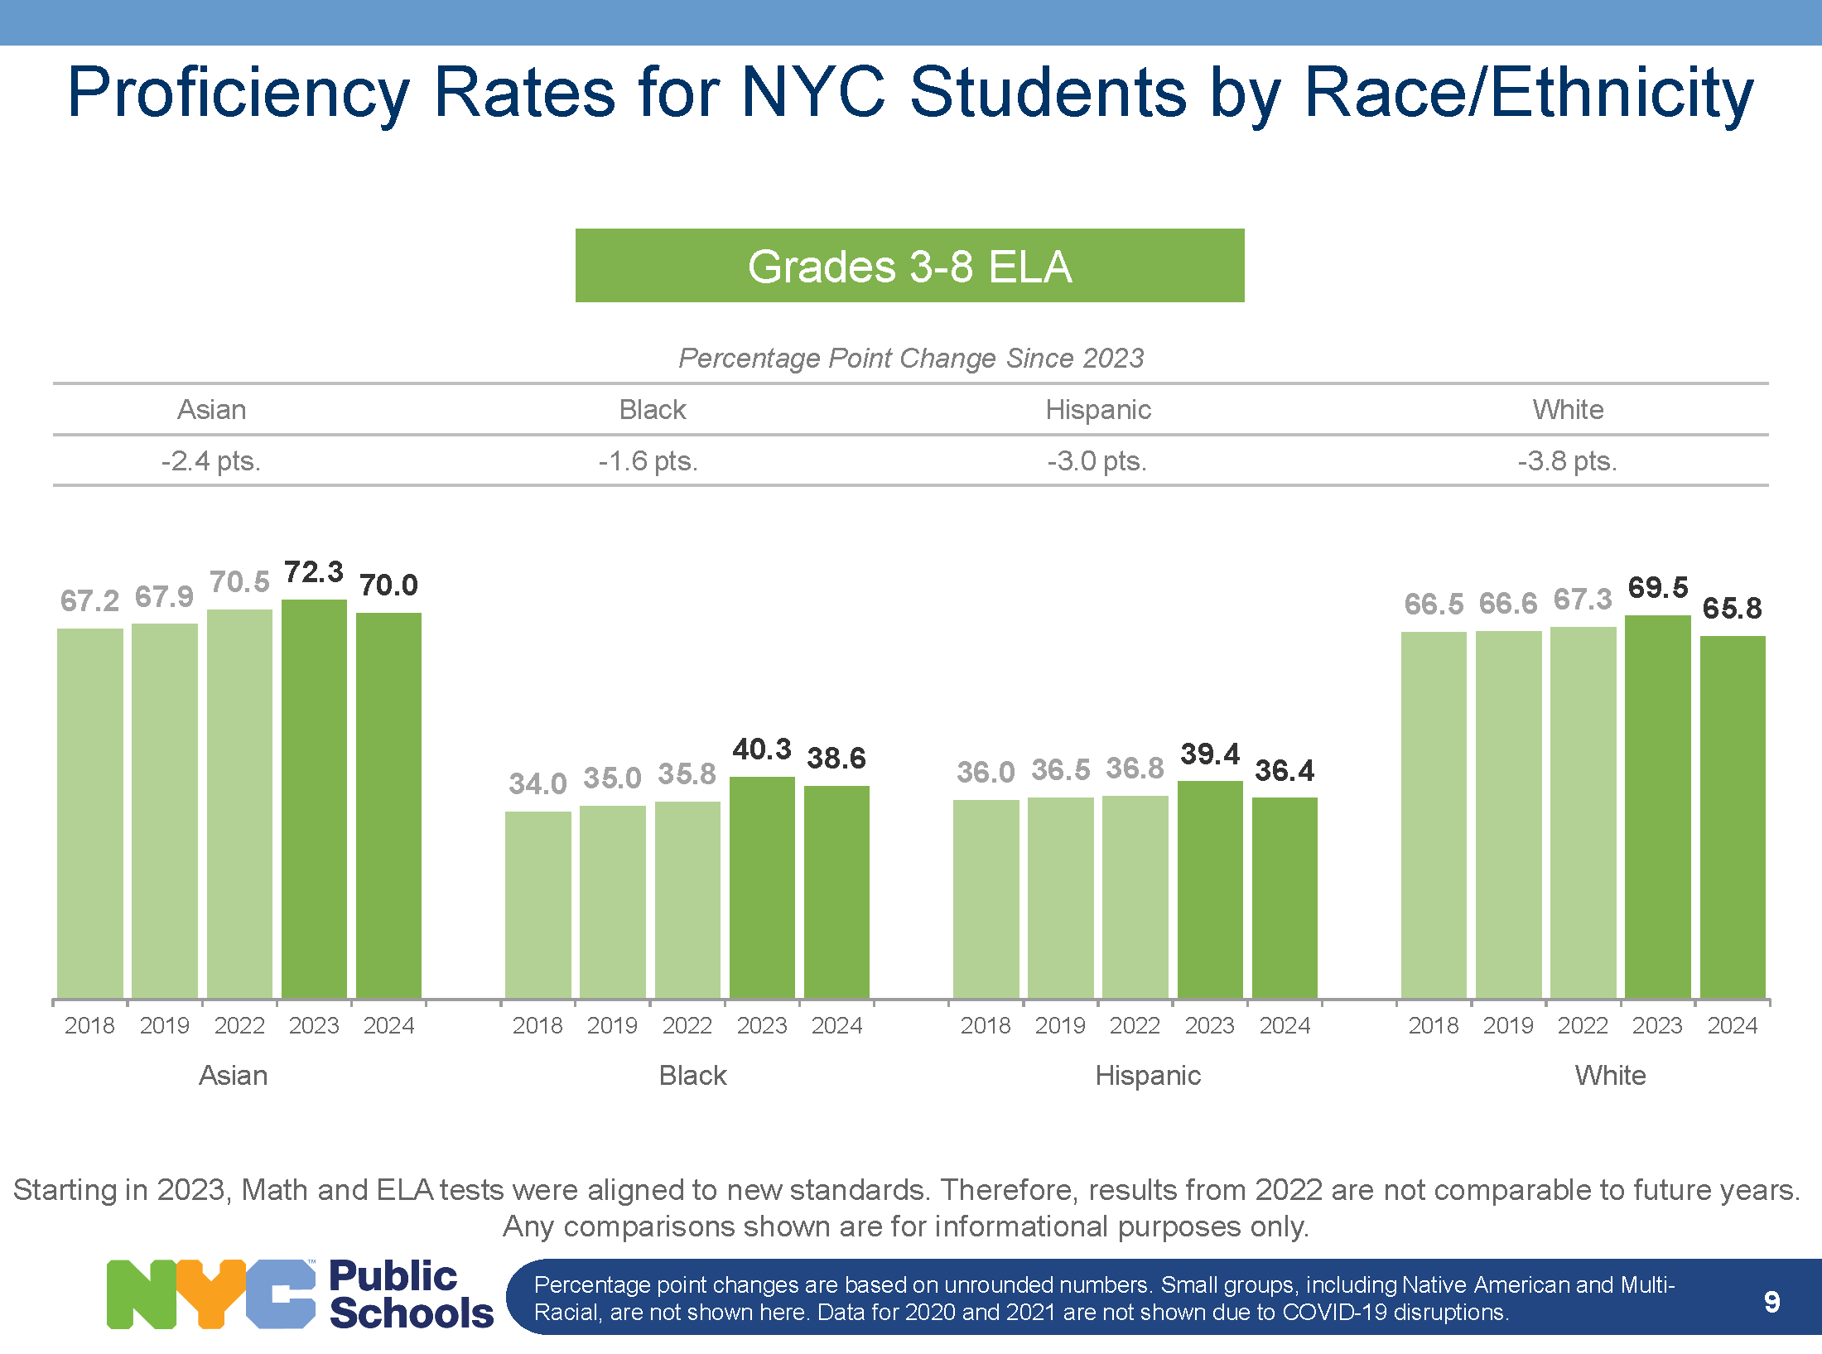

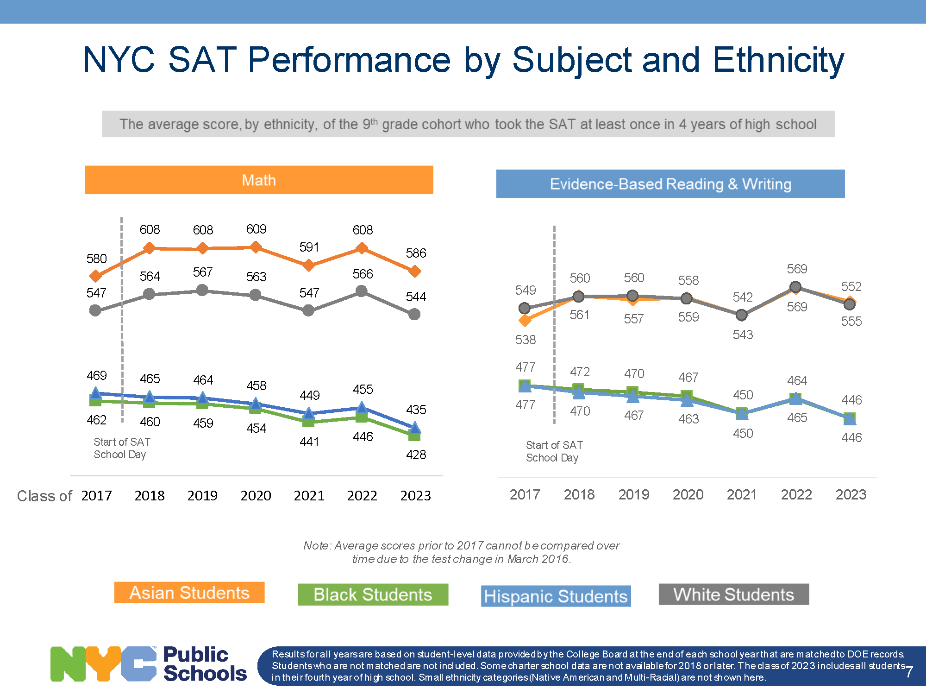

1. <https://www.gothamgazette.com/government/5392-the-history-of-new-york-citys-special-high-schools-timeline>
2. <https://www.nytimes.com/2024/06/18/nyregion/nyc-specialized-high-school-admissions-black-and-latino-students.html>
3. Kobrin, J.E., & Anderson, A. (2019). The Official SAT Study Guide. New York, NY: The College Board
4. <https://infohub.nyced.org/reports/academics/test-results>
5. Ibid.